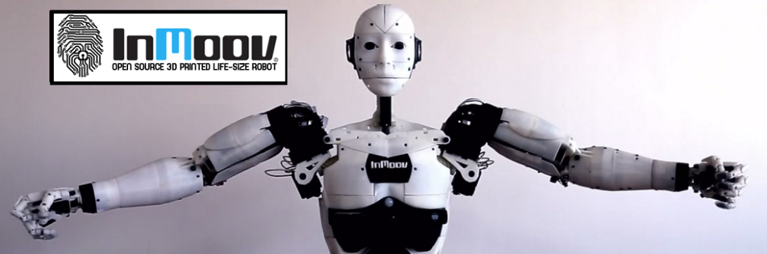

**Presentation & Subject Analysis**

**Identification:**

|  |  |
| --- | --- |
| Project Title | Robot Cognitif |
| Project Number | 65 |
| Team Referent | MARTIN Jérémy |
| Other members in team | EKHTERAEI Aria, GUILLAUME Thomas, MEZOUAR Chloé |
| Team Mentor | Jean-Philippe LELIEVRE |
| Project Partner | DaVinciBot |

**Work done since the last PRM review:**

-We did the 2nd project review of the year on February 13th about the project progress.

-We began to think about the poster we will expose during the showroom. We saw with the other teams if we could agree on a communal base like the colors or the typography for example.

-We also began to think about the migration of the code on the robot with myrobotlab.

-We started to write the project closure report.

**Difficulties encountered:**

-There are many things to manage apart from the project like many little projects for other courses, the search for an internship, the preparation for the international semester, ...

-Importing the code in the robot with myrobotlab will be harder than we thought.

-It is not easy for us to find moments in our schedule where we can meet.